
GRPAHIC USER INTERFACE

Threat Receiver in Alarm
Motion Detector in Alarm—Subject is within 20 ft.
Camera Icon—Left Click Accesses Live Video
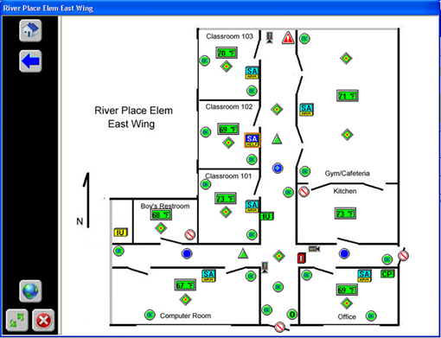

a

Tactical Workstation w/ video pulled
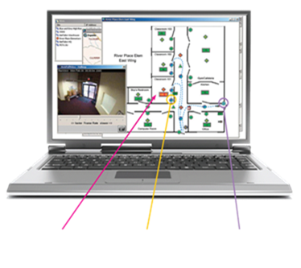
Sensor Multistate Conditions Provide
Continuous Real-time Actionable
Intelligence

Hot Zones Centered on Motion Detectors
Motion are in disarmed condition—Normal School Day

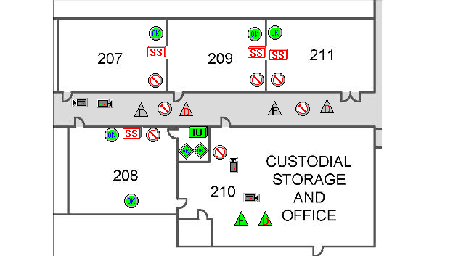
Figure 7 - Counter Measures Monitoring Screen

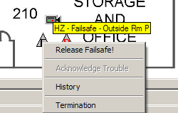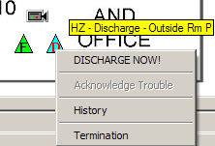

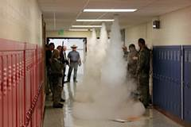
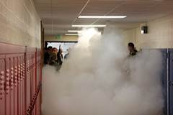
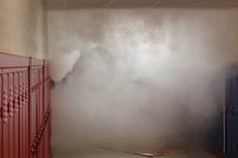
Figure 8 - Counter Measures Released

